CHUONG 11: SAN CHUOI

NGUYEN QUANG DONG

October 13, 2020

# BAT TAP: Data = oil.txt

# Mo hinh: SMS, HOLT-WINTERS

# Call packages for estimating, test

setwd("D:/TH_RStudio")  
library(foreign); library(car); library(carData)

## Loading required package: carData

library(lmtest);library(zoo)

## Loading required package: zoo

##   
## Attaching package: 'zoo'

## The following objects are masked from 'package:base':  
##   
## as.Date, as.Date.numeric

library(sandwich); library(survival)  
library(AER); library(stargazer)

##   
## Please cite as:

## Hlavac, Marek (2018). stargazer: Well-Formatted Regression and Summary Statistics Tables.

## R package version 5.2.2. https://CRAN.R-project.org/package=stargazer

library(ggplot2)  
library(forecast)

## Registered S3 method overwritten by 'quantmod':  
## method from  
## as.zoo.data.frame zoo

## I.INPUT DATA

data_oil=read.table("D:/dataR/oil.txt", header=TRUE)  
data_oil

## year y  
## 1 1996 445.36  
## 2 1997 453.20  
## 3 1998 454.41  
## 4 1999 422.38  
## 5 2000 456.04  
## 6 2001 440.39  
## 7 2002 425.19  
## 8 2003 486.21  
## 9 2004 500.43  
## 10 2005 521.28  
## 11 2006 508.95  
## 12 2007 488.89  
## 13 2008 509.87  
## 14 2009 456.72  
## 15 2010 473.82  
## 16 2011 525.95  
## 17 2012 549.83  
## 18 2013 542.34

oil=data_oil$y  
oil

## [1] 445.36 453.20 454.41 422.38 456.04 440.39 425.19 486.21 500.43 521.28  
## [11] 508.95 488.89 509.87 456.72 473.82 525.95 549.83 542.34

oil=ts(oil,start=1996, frequency=1)  
oil

## Time Series:  
## Start = 1996   
## End = 2013   
## Frequency = 1   
## [1] 445.36 453.20 454.41 422.38 456.04 440.39 425.19 486.21 500.43 521.28  
## [11] 508.95 488.89 509.87 456.72 473.82 525.95 549.83 542.34

## SAN MU GIAN GIAN DON - SINGLE EXPONENTIAL SMOOTHING - MOT THAM SO

plot(oil)

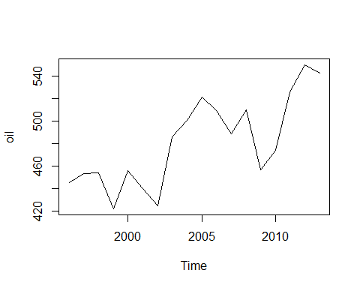

oilses=ses(oil,h=5)  
summary(oilses)

##   
## Forecast method: Simple exponential smoothing  
##   
## Model Information:  
## Simple exponential smoothing   
##   
## Call:  
## ses(y = oil, h = 5)   
##   
## Smoothing parameters:  
## alpha = 0.8339   
##   
## Initial states:  
## l = 446.5649   
##   
## sigma: 29.8295  
##   
## AIC AICc BIC   
## 178.1445 179.8588 180.8156   
##   
## Error measures:  
## ME RMSE MAE MPE MAPE MASE ACF1  
## Training set 6.403552 28.12351 22.25903 1.097903 4.61071 0.9256448 -0.03380699  
##   
## Forecasts:  
## Point Forecast Lo 80 Hi 80 Lo 95 Hi 95  
## 2014 542.6795 504.4515 580.9076 484.2148 601.1443  
## 2015 542.6795 492.9048 592.4543 466.5556 618.8035  
## 2016 542.6795 483.5723 601.7868 452.2827 633.0763  
## 2017 542.6795 475.5244 609.8347 439.9746 645.3845  
## 2018 542.6795 468.3427 617.0163 428.9912 656.3679

plot(oilses)

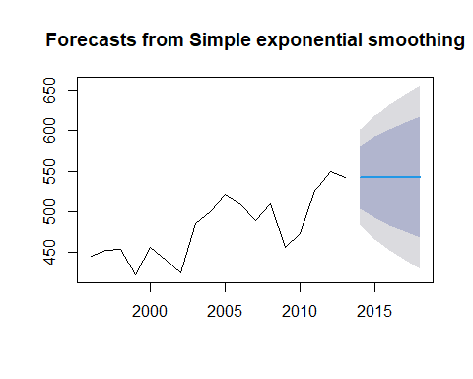

round(accuracy(oilses,2))

## ME RMSE MAE MPE MAPE MASE ACF1  
## Training set 6 28 22 1 5 1 0  
## Test set -541 541 541 -27034 27034 22 NA

autoplot(oilses)+  
 autolayer(fitted(oilses),seriers="Fitted")+  
 ylab("oil")+xlab("Year")

## Warning: Ignoring unknown parameters: seriers

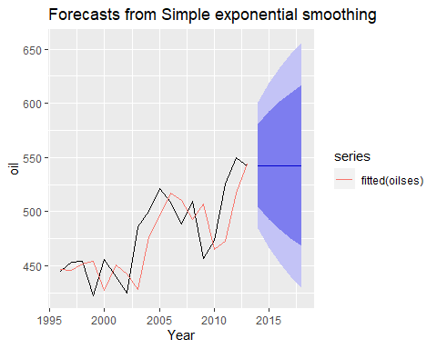 ## HOLT-WINTRES SAN CHUOI CO XU THE, KHONG CO YEU TO THOI VU - HAI THAM SO

oilhw1=holt(oil,h=5)  
summary(oilhw1)

##   
## Forecast method: Holt's method  
##   
## Model Information:  
## Holt's method   
##   
## Call:  
## holt(y = oil, h = 5)   
##   
## Smoothing parameters:  
## alpha = 1e-04   
## beta = 1e-04   
##   
## Initial states:  
## l = 428.483   
## b = 5.5757   
##   
## sigma: 27.8702  
##   
## AIC AICc BIC   
## 177.2951 182.2951 181.7469   
##   
## Error measures:  
## ME RMSE MAE MPE MAPE MASE  
## Training set -0.2711669 24.57917 20.53694 -0.3257339 4.338246 0.8540311  
## ACF1  
## Training set 0.3429167  
##   
## Forecasts:  
## Point Forecast Lo 80 Hi 80 Lo 95 Hi 95  
## 2014 534.4099 498.6929 570.1270 479.7854 589.0344  
## 2015 539.9851 504.2680 575.7021 485.3606 594.6096  
## 2016 545.5602 509.8431 581.2772 490.9357 600.1847  
## 2017 551.1353 515.4183 586.8524 496.5108 605.7598  
## 2018 556.7104 520.9934 592.4275 502.0859 611.3350

autoplot(oilhw1)+  
 autolayer(fitted(oilhw1),series="Fitted")+  
 ylab("Oil")+ xlab("Year")

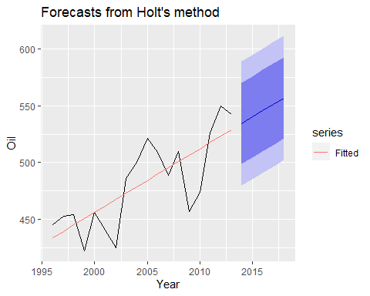 ## HOLT-WINTRES SAN CHUOI CO XU THE, CO YEU TO THOI VU - BA THAM SO

ch12bt20=read.table("D:/dataR/ch12bt20.txt",header=TRUE)  
ch12bt20

## GDP PDI PCE PROFIT DIVIDENT  
## 1 2872.8 1990.6 1800.5 44.7 24.5  
## 2 2860.3 2020.1 1807.5 44.4 23.9  
## 3 2896.6 2045.3 1824.7 44.9 23.3  
## 4 2873.7 2045.2 1821.2 42.1 23.1  
## 5 2942.9 2073.9 1849.9 48.8 23.8  
## 6 2947.4 2098.0 1863.5 50.7 23.7  
## 7 2966.0 2106.6 1876.9 54.2 23.8  
## 8 2980.8 2121.1 1904.6 55.7 23.7  
## 9 3037.3 2129.7 1929.3 59.4 25.0  
## 10 3089.7 2149.1 1963.3 60.1 25.5  
## 11 3125.8 2193.9 1989.1 62.8 26.1  
## 12 3175.5 2272.0 2032.1 68.3 26.5  
## 13 3253.3 2300.7 2063.9 79.1 27.0  
## 14 3267.6 2315.2 2062.0 81.2 27.8  
## 15 3264.3 2337.9 2073.7 81.3 28.3  
## 16 3289.1 2382.7 2067.4 85.0 29.4  
## 17 3259.4 2334.7 2050.8 89.0 29.8  
## 18 3267.6 2304.5 2059.0 91.2 30.4  
## 19 3239.1 2315.0 2065.5 97.1 30.9  
## 20 3226.4 2313.7 2039.9 86.8 30.5  
## 21 3154.0 2282.5 2051.8 75.8 30.0  
## 22 3190.4 2390.3 2086.9 81.0 29.7  
## 23 3249.9 2354.4 2114.4 97.8 30.1  
## 24 3292.5 2389.4 2137.0 103.4 30.6  
## 25 3356.7 2424.5 2179.3 108.4 32.6  
## 26 3369.2 2434.9 2194.7 109.2 35.0  
## 27 3381.0 2444.7 2213.0 110.0 36.6  
## 28 3416.3 2459.5 2242.0 110.3 38.3  
## 29 3466.4 2463.0 2271.3 121.5 39.2  
## 30 3525.0 2490.3 2280.8 129.7 40.0  
## 31 3574.4 2541.0 2302.6 135.1 41.4  
## 32 3567.2 2556.2 2331.6 134.8 42.4  
## 33 3591.8 2587.3 2347.1 137.5 43.5  
## 34 3707.0 2631.9 2394.0 154.0 44.5  
## 35 3735.6 2653.2 2404.5 158.0 46.6  
## 36 3779.6 2680.9 2421.6 167.8 48.9  
## 37 3780.8 2699.2 2437.9 168.2 50.5  
## 38 3784.3 2697.6 2435.4 174.1 51.8  
## 39 3807.5 2715.3 2454.7 178.1 52.7  
## 40 3814.6 2728.1 2465.4 173.4 54.5  
## 41 3830.8 2742.9 2464.6 174.3 57.6  
## 42 3732.6 2692.0 2414.2 144.5 58.7  
## 43 3733.5 2722.5 2440.3 151.0 59.3  
## 44 3808.5 2777.0 2469.2 154.6 60.5  
## 45 3860.5 2783.7 2475.5 159.5 64.0  
## 46 3844.4 2776.7 2476.1 143.7 68.4  
## 47 3864.5 2814.1 2487.4 147.6 71.9  
## 48 3803.1 2808.8 2468.6 140.3 72.4  
## 49 3756.1 2795.0 2484.0 114.4 70.0  
## 50 3771.1 2824.8 2488.9 114.0 68.4  
## 51 3754.4 2829.0 2502.5 114.6 69.2  
## 52 3759.6 2832.6 2539.3 109.9 72.5  
## 53 3783.5 2843.6 2556.5 113.6 77.0  
## 54 3886.5 2867.0 2604.0 133.0 80.5  
## 55 3944.4 2903.0 2639.0 145.7 83.1  
## 56 4012.1 2960.6 2678.2 141.6 84.2  
## 57 4089.5 3033.2 2703.8 155.1 83.3  
## 58 4144.0 3065.9 2741.1 152.6 82.2  
## 59 4166.4 3102.7 2754.6 141.8 81.7  
## 60 4194.2 3118.5 2784.8 136.3 83.4  
## 61 4221.8 3123.6 2824.9 125.2 87.2  
## 62 4254.8 3189.6 2849.7 124.8 90.8  
## 63 4309.0 3156.5 2893.3 129.8 94.1  
## 64 4333.5 3178.7 2895.3 134.2 97.4  
## 65 4390.5 3227.5 2922.4 109.2 105.1  
## 66 4387.7 3281.4 2947.9 106.0 110.7  
## 67 4412.6 3272.6 2993.7 111.0 112.3  
## 68 4427.1 3266.2 3012.5 119.2 111.0  
## 69 4460.0 3295.2 3011.5 140.2 108.0  
## 70 4515.3 3241.7 3046.8 157.9 105.5  
## 71 4559.3 3285.7 3075.8 169.1 105.1  
## 72 4625.5 3335.8 3074.6 176.0 106.3  
## 73 4655.3 3380.1 3128.2 195.5 109.6  
## 74 4704.8 3386.3 3147.8 207.2 113.3  
## 75 4734.5 3407.5 3170.6 213.4 117.5  
## 76 4779.7 3443.1 3202.9 226.0 121.0  
## 77 4809.8 3473.9 3200.9 221.3 124.6  
## 78 4832.4 3450.9 3208.6 206.2 127.1  
## 79 4845.6 3466.9 3241.1 195.7 129.1  
## 80 4859.7 3493.0 3241.6 203.0 130.7  
## 81 4880.8 3531.4 3258.8 199.1 132.3  
## 82 4900.3 3545.3 3258.6 193.7 132.5  
## 83 4903.3 3547.0 3281.2 196.3 133.8  
## 84 4855.1 3529.5 3251.8 199.0 136.2  
## 85 4824.0 3514.8 3241.1 189.7 137.8  
## 86 4840.7 3537.4 3252.4 182.7 136.7  
## 87 4862.7 3539.9 3271.2 189.6 138.1  
## 88 4868.0 3547.5 3271.1 190.3 138.5

GDP=ch12bt20$GDP  
GDP=ts(GDP, start=c(1970,1), frequency=4)  
GDP

## Qtr1 Qtr2 Qtr3 Qtr4  
## 1970 2872.8 2860.3 2896.6 2873.7  
## 1971 2942.9 2947.4 2966.0 2980.8  
## 1972 3037.3 3089.7 3125.8 3175.5  
## 1973 3253.3 3267.6 3264.3 3289.1  
## 1974 3259.4 3267.6 3239.1 3226.4  
## 1975 3154.0 3190.4 3249.9 3292.5  
## 1976 3356.7 3369.2 3381.0 3416.3  
## 1977 3466.4 3525.0 3574.4 3567.2  
## 1978 3591.8 3707.0 3735.6 3779.6  
## 1979 3780.8 3784.3 3807.5 3814.6  
## 1980 3830.8 3732.6 3733.5 3808.5  
## 1981 3860.5 3844.4 3864.5 3803.1  
## 1982 3756.1 3771.1 3754.4 3759.6  
## 1983 3783.5 3886.5 3944.4 4012.1  
## 1984 4089.5 4144.0 4166.4 4194.2  
## 1985 4221.8 4254.8 4309.0 4333.5  
## 1986 4390.5 4387.7 4412.6 4427.1  
## 1987 4460.0 4515.3 4559.3 4625.5  
## 1988 4655.3 4704.8 4734.5 4779.7  
## 1989 4809.8 4832.4 4845.6 4859.7  
## 1990 4880.8 4900.3 4903.3 4855.1  
## 1991 4824.0 4840.7 4862.7 4868.0

GDPAD= hw(GDP,seasonal="additive")  
summary(GDPAD)

##   
## Forecast method: Holt-Winters' additive method  
##   
## Model Information:  
## Holt-Winters' additive method   
##   
## Call:  
## hw(y = GDP, seasonal = "additive")   
##   
## Smoothing parameters:  
## alpha = 0.9999   
## beta = 0.2796   
## gamma = 1e-04   
##   
## Initial states:  
## l = 2863.6881   
## b = 23.8571   
## s = -2.3876 0.5949 1.7513 0.0414  
##   
## sigma: 37.4677  
##   
## AIC AICc BIC   
## 1041.351 1043.658 1063.647   
##   
## Error measures:  
## ME RMSE MAE MPE MAPE MASE  
## Training set -0.7461287 35.72402 27.06421 -0.01268386 0.736728 0.2345349  
## ACF1  
## Training set 0.1267068  
##   
## Forecasts:  
## Point Forecast Lo 80 Hi 80 Lo 95 Hi 95  
## 1992 Q1 4875.927 4827.910 4923.944 4802.492 4949.362  
## 1992 Q2 4883.137 4805.161 4961.113 4763.883 5002.391  
## 1992 Q3 4887.481 4779.384 4995.578 4722.161 5052.801  
## 1992 Q4 4889.990 4750.418 5029.562 4676.534 5103.447  
## 1993 Q1 4897.917 4725.210 5070.624 4633.785 5162.050  
## 1993 Q2 4905.127 4697.556 5112.698 4587.675 5222.580  
## 1993 Q3 4909.471 4665.307 5153.635 4536.055 5282.888  
## 1993 Q4 4911.980 4629.528 5194.432 4480.008 5343.953

GDPMU= hw(GDP,seasonal="multiplicative")  
summary(GDPMU)

##   
## Forecast method: Holt-Winters' multiplicative method  
##   
## Model Information:  
## Holt-Winters' multiplicative method   
##   
## Call:  
## hw(y = GDP, seasonal = "multiplicative")   
##   
## Smoothing parameters:  
## alpha = 0.9964   
## beta = 0.1353   
## gamma = 0.0036   
##   
## Initial states:  
## l = 2864.0245   
## b = 23.0339   
## s = 0.9994 1.0005 1.0004 0.9997  
##   
## sigma: 0.0104  
##   
## AIC AICc BIC   
## 1051.548 1053.856 1073.844   
##   
## Error measures:  
## ME RMSE MAE MPE MAPE MASE  
## Training set -1.031653 36.03896 27.21955 -0.01981059 0.740881 0.2358811  
## ACF1  
## Training set 0.2492981  
##   
## Forecasts:  
## Point Forecast Lo 80 Hi 80 Lo 95 Hi 95  
## 1992 Q1 4880.352 4815.272 4945.431 4780.821 4979.882  
## 1992 Q2 4894.370 4795.921 4992.818 4743.806 5044.934  
## 1992 Q3 4905.491 4776.856 5034.126 4708.761 5102.221  
## 1992 Q4 4911.016 4753.186 5068.846 4669.636 5152.397  
## 1993 Q1 4923.385 4736.032 5110.738 4636.854 5209.916  
## 1993 Q2 4937.432 4720.227 5154.637 4605.246 5269.618  
## 1993 Q3 4948.556 4701.029 5196.084 4569.995 5327.118  
## 1993 Q4 4954.036 4675.812 5232.260 4528.529 5379.542

autoplot(GDP)+  
 autolayer(GDPAD, series="HW additive forecasts", PI=FALSE)+  
 autolayer(GDPMU, series="HW multiplicative forecasts", PI=FALSE)+  
 xlab("Year")+  
 ylab("GDP of USA")+  
 ggtitle(" FORECAST GDP OF USA BY HOLT-WINTERS")+  
 guides(colour=guide_legend(title="Forecast"))

